A Methodology for Integrating Web Based FMEA and TRIZ
Ammar Ali Awad¹* and Sha’ri Mohd. Yusof ²
¹Razak School of Engineering and Advanced Technology, Universiti Teknologi Malaysia
² Department of Manufacturing & Industrial Engineering, Universiti Teknologi Malaysia
* Corresponding author, E-mail: ammarpt73@yahoo.com

Abstract
Failure Mode and Effect Analysis (FMEA) is a problem prevention technique predominantly used in industry. The applications of FMEA in Malaysia’s automotive manufacturing firms are currently manually done on hard copies or into spreadsheets. However, these conventional approaches are not highly effective, since they are not living documents, and they involve tedious data maintenance and updating. Above that, the recommended actions are usually taken based on the accumulation of experience based on personal memory. This research aims to convert a traditional process FMEA approach into an open architecture Process FMEA Web–based system, in conjunction with the automotive standard control plans, and to integrate invention problem solving methods (TRIZ) with this Web-based system. The Web-Based PFMEA model was validated using PFMEA data and failure reports provided by the Malaysian automotive manufacturing. This approach will help the process engineer to take action proactively when updating PFMEA and to improve or modify process control plans at a much lower cost. Integrated TRIZ with Web-based PFMEA can further assist in solving problems quickly and effectively. It also support engineers to look for the most highly effective and creative solutions.
Keywords: FMEA, Internet Applications in Manufacturing, Web-Based Technology, TRIZ.

Introduction
FMEA is a methodology designed for identifying potential failure modes for a product or process, assessing the risk associated with those failure modes, ranking the issues in terms of importance, and identifying and carrying out corrective actions to address the most serious concerns.
Currently, FMEA has become a very important item among quality tools and has been increasingly adopted in manufacturing industries worldwide. In addition, FMEA has become standard practice in Japanese, American, and European manufacturing companies. For example, MIL-STD 1629A is the most widely used FMEA standard in the USA, similar to BS 5760 in the UK. .
In 1990, the International Organization for Standardization (ISO) recommended the use of FMEA for design review in the ISO 9000 series .
Basically, there are two main types of FMEA: design FMEA and process FMEA. Design FMEA is used in identifying design failures for products, machines, or tooling, while process FMEA is applied in the analysis of manufacturing processes prior to developing tooling or manufacturing equipment. In both cases, the effects of the failures are identified and the risks assessed accordingly .
Teamwork is critical to the success of the FMEA process. Therefore, the FMEA team from various departments must work in coordination and gather the required information to develop an effective FMEA report. The FMEA team must then analyze failure modes for each process involved in a product, and subsequently determine the potential causes and effects. Finally, the risk of each failure is prioritized based on the risk priority number (RPN).
RPN is a decision factor that provides a relative risk ranking. The higher the value of RPN, the higher is the potential risk. RPN is calculated for each failure mode and effect by multiplying the three rankings, that is, Multiply the The Severity of the effect, the frequency Occurrence of the cause of the failure, and the ability to detect (or prevent) the failure or effect.
The ranking of the occurrence, the severity, and the detection method are based on a 1 to 10 scale.

Teoh (2005) stated that the traditional approach of conducting FMEA has several weaknesses. For example, the approach used for analyzing failure and problem solving is brainstorming, which can create many ideas, but most of which are not useful when solving problems. Also, the method used for recording the FMEA report is unsuitable for reuse as this method is recorded manually onto hard copies or into spreadsheets. With the development of the FMEA, it will thus become increasingly difficult to find specific information.
In the case of large and complex systems, the traditional approach offers restricted support for team members in carrying out an effective FMEA, and does not provide dynamic usage of information relations .
However, it is increasingly difficult to use these techniques when the complexity of the system makes failure propagation hard to derive, often missing key failures. In addition, an FMEA developed late has no impact on key product and process decision- making.
Moreover, in the traditional approach, the PFMEA is first utilized followed by the control plan process based on the risks identified, while a vital enhancement can be achieved through process control plans, and a dynamic PFMEA is used when updating the PFMEA or indicating internal /external failures and improving or modifying process control plan.
According to Daniele et al. (2011), it is becoming increasingly critical to manage risk in the product-development process, and traditional tools such as QFD and FMEA are not enhanced enough to address the risk. Therefore, there is a potential limitation if these tools are used separately. Thus, integrating the FMEA technique with other methodologies used in product development, production, and maintenance will enhance FMEA capabilities.
TRIZ inventive problem-solving approach can help in situations where unexpected problems have occurred and where the source or cause of the problem is unknown. TRIZ, the Theory of Inventive Problem Solving, a systematic approach that improves a team’s ability to solve problems, was founded by G.S.Altshuller, a Russian inventor, in 1946. Currently, it is becoming a powerful methodology in the developed countries of the world in research and application by producing systematic innovation and improving quality .
One way of dealing with the improvement of FMEA is to develop and apply a web-based system. There are high expectations that web-based manufacturing technology can and will provide satisfactory information to support integration and collaboration among the different partners of the product development team. Such a system can also improve product quality and reduce the cycle time and cost of product development, thus providing better global competitiveness of products in the marketplace.
The current research introduces a support tool for a web technology that will allow the involvement of FMEA process services on the internet to overcome the above limitations. In addition, by adopting the FMEA web-based system, an automotive manufacturing firm will be able to improve the efficiency and quality of product design production life-cycle integration, enterprise management, and customer service. Further, integrating the PFMEA web-based system with a control plan will activate the monitoring process and operation as a living document.
At the same time, the web-based PFMEA system is integrated with the TRIZ invention problem solving method. This facilitates a collaborative manufacturing environment for the team members, and makes up for the lack of design experience for new processes and products. This approach can also be used in the refining process phases, thereby making efficient improvements such as avoiding excessive brainstorming by shortening the time required. Recommendations arising from TRIZ contradiction matrix help engineers search for feasible solutions. As a result, better communication will be achieved, enabling team members from different departments to carry out product development activities as well as improve their ability to solve problems.

- Theory of Inventive problem Solving (TRIZ)
TRIZ "Teoriya Resheniya Izobreatatelskikh Zadatch" is the Russian acronym for Theory of Inventive Problem Solving. Originated in the late of 1940’s, in the former Soviet Union as an attempt to develop a method, which would support a process of generating new ideas and finding solutions in a systematic way (Souchkov, 2007).
According to Savransky (2000) TRIZ is a human-oriented knowledge-based systematic methodology of inventive problem solving.
The originator of TRIZ Genrikh Altshuller and his colleagues started development of this methodology. It is a problem solving methodology based on a systematic logic approach that was developed from reviewing thousands of patents and analysis of technology evolution. TRIZ can be used as a powerful for igniting the creative imagination to solve simple and difficult technical and technological problems more quickly and with better results (Kim et al., 2009).
The basic strategy of TRIZ is that " In most cases the problem we’re facing now, has already been faced by many other people at different times, at different places and in different situation, and most likely been solved in different ways". The TRIZ approach as shown in Fig. 1. is to "find the solution from those solutions" and allows connecting the problem to a standard problem and suggesting a standard solution, which provide the direction to follow to determine the best solution for the problem overcoming contradictions (John T. et al., 2000).
There are various methods and tools in TRIZ innovation technology, which over the years have proven to be successful, including Problem Formulation, Contradiction Matrix, 40 Inventive Principles, Functional Analysis, Separation Principles, Substance-Field, Ideal Final Result, Effects, ARIZ, etc. Users can select appropriate tools to solve their problem depending on the type of problems (Tien-and Shao, 2011).
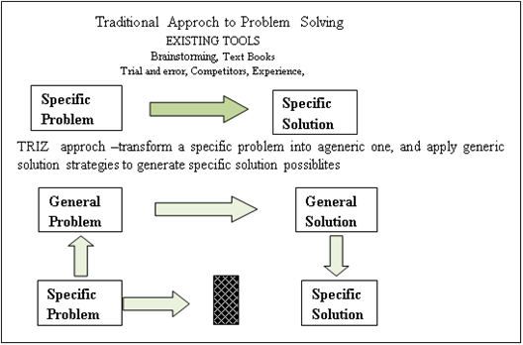
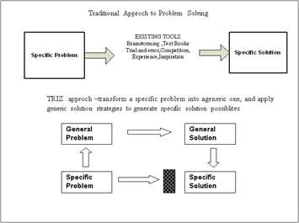

- Related Works

It is recognized that the tedious of traditional FMEA approach make it not effectively used by Industries. Hence, researchers have been interested in automating FMEA to improve its usability and Several approaches have been highlighted in various studies to address the problems related to FMEA using different techniques and a number of collaborative product development systems or platforms have been developed. As a result, many commercial software packages have been developed (Huang and . Mak, 2000).
Besides the productivity increase and data management benefits of such commercial programs, several issues limit their use at an industry-wide level, such as implementation costs, stand-alone, compatibility issues and they offer limited support for participation of team member over distance .
Neagoe (2010) stated that although, many automotive companies adopted FMEA since 1980, there are no real benefits that have been gained from the use of this technique in these companies, due to several important issues such as, the long time needed for the application of the analysis process, the ambiguity of certain technical aspects and the tedious project management lead to a difficult acceptance of the method to achieve the real improvements.
Kaufman and Sato (2004), pointed out that most automotive suppliers carry out FMEAs to placate their automotive manufacturers, or only because it is required by standards and regulations or specifically requested in their customer demands, and thus fail to consider and obtain the highest level of benefits.
Daniel (2006) stated that the use of process control plans coupled with a dynamic failure mode effects analysis can spot potential high-risk process failures before they occur allowing the process engineer to take action proactively at a much lower cost.

A prototype software was created by Teoh (2005) and was evaluated using case studies from design and manufacture. However, there are some weaknesses from the prototype that needs further improvement, before it can be used in actual working environment. These limitations are its inability to represent different instances of the same model, to model logical processes, and to represent a dynamic behavior.
Huang (2002) argued that stand-alone FMEA software packages are unsuitable for team members in the FMEA process. They developed a prototype web-based FMEA platform that can be accessed by members at disparate locations via the internet.
Fig. 1. Comparison between traditional and TRIZ
approach to innovation
Huang and Mak (2000) developed a Web-based Failure Mode and Effect Analysis (FMEA) system for diagnosis and quality control. This system is composed of a Web server, a database server, and clients which provides better support for teamwork Remote and simultaneous access. A full evaluation of the system has not been conducted due to bugs in the implementation codes.
Neagoe (2011) pointed out that the geographic distribution of automotive production sites, and the development of the IT and communication infrastructure offer the possibility of using computer-aided management systems for the FMEA, with a web-based infrastructure that facilitates long distance collaboration, an essential requirement in multinational companies.
Johnson and Khan (2003) had conducted a study on the use of PFMEA in the automotive industries in the UK. He had established method on determining the effectiveness of FMEA . The study concluded that the PFMEA technique has limitations caused by issues such as the understanding of cause and effect and the practical aspects of managing the data and keeping it up to date. It was indicated that the suppliers found it difficult to quantify the true benefits of the PFMEA technique, in terms of costs, reliability improvements, and problem prevention.
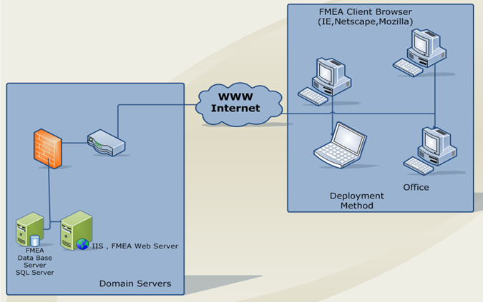
Chung and Teng (2010) reported that the integrated (QFD)/ AHP (Analytic Hierarchy Process) and TRIZ/FMEA for constructing the pattern of product design. This method can be practically used for a design strategic process executed in an enterprise. Such integration provides engineers an approach to convert customer's requirements to engineering parameters, avoid narrow thinking for products, and create new ideas.
Neagoe (2010) reported that using a FMEA web-based application allowed the participation of team members over distance, well suited for automotive international companies, with an efficient data-management system and capability to reuse valuable FMEA information. Other advantages of using a computer-aided FMEA management system could be the integration with other reliability tools, various result reporting capabilities and the possibility to develop more complex risk-assessment models (integrating new factors such as costs) and automation capabilities.
Darrell Mann (2000) pointed out that TRIZ is being integrated with other systematic innovation methodologies such as Six Sigma, FMEA, QFD, DFMA and Lean Manufacturing. The combined methods are beginning to be applied successfully across a number of widely disparate problem types.
Yen (2005) proposed a tool instead of traditional FMEA that emphasized environmental, safety and healthy operations during the product's life cycle to evaluate the priority to remove the failures or reduce their risks, by integrating the TRIZ invention problem solving method.
- Proposed method
4.1 Web–Based FMEA architecture
Internet–based technology has in recent years become widespread because it allows global and easy access to data and information from anywhere. One of the greatest advantages of web-based technology is that the system does not need complicated functions. Furthermore, the low cost of application has further popularized its use (Jui-Sheng 2008).
A proposed prototype for web based PFMEA system runs on PFMEA web server and interacts with PFMEA clients through dynamic Web page internet information Server (IIS), a powerful web server released by Microsoft, which provides a highly reliable, manageable, and scalable Web application. It communicates with the FMEA database server, and all of these components are, linked through the internet. Fig. 2. gives an overview of setting up the components.

Fig.2. Web - Based FMEA Deployment

The Architecture consists of four main components, namely, Presentation Layer, Business Object layer, Data Access Layer and Resource Layer. Fig.3 shows Web–Based FMEA Framework Architecture.

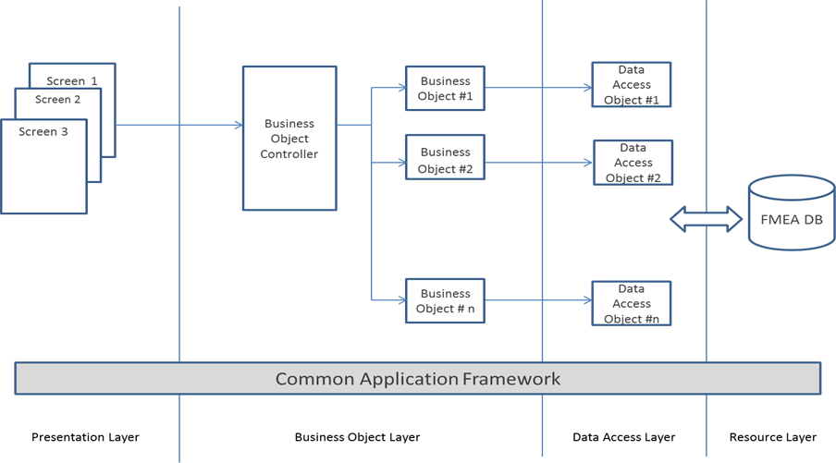
Fig. 3. Web–Based FMEA Framework Architecture
Presentation layer
A standard Internet Browser such as Internet Explorer is the primary client for the PFMEA application. HTML pages are delivered to the client browser by the FMEA application upon user request.
In the presentation layer, the code-behind mechanism for ASP.NET pages and controls like text box, labels, command buttons, user controls, etc., are the prominent example of a layered design. The markup file defines the look and layout of the web form and the code behind file contains the presentation logic. It’s a clean separation because both the markup and the code-behind layers house specific sets of functionality that benefit from being apart. It is also easy to maintain the design file and logic file separately.
Business Object Layer
The Business layer will implement the business rules for the application. It will host the business service components as well as business object (BO). These Business Services include Business Objects Controller including the .NET classes that will provide service API’s to the business rules and operations required by the application. The business components are software units, and process business logic.
The business components will implement the following:

- Business rules, such as calculations and validations.
- Interfaces between the user Interface and the resource layer.
The business logic layer will run under the “Application Server” environment. Application Servers provide support for transaction control, thread management and other run-time services that make application development much simpler and reliable. Business components are generally computation-intensive. They will use Data Access Objects (DAO) to communicate with the database. The Business layer consists of:
- .NET classes: used to manage the data flow between the layers. Net classes on the other hand are simple .NET objects that provide utilities to the application. They may also contain business logic and provide other supporting services.
Data Access Layer
Data Access Objects using SQL DB connectivity will manage the interface to the database. Persistence can be complex in large applications using protocols like http. Neither the client nor the business component needs to be aware of this complexity. Moreover, there are many forms of storage ranging from databases to flat files. Decoupling the persistence logic from the business components and client allows for a flexible, easy to maintain application. The Data Access Object patter allows for the abstraction of the persistence from the business component. The Data Access Object manages the connection to the data source to obtain and store data. It encapsulates all access to the data store.
Resource Layer
The resource layer includes the underlying resources that the application uses to deliver its functionality. This includes using a Database and file system information.

4.2 Web–Based PFMEA System development
The FMEA Web based system was carried out through different platforms on the internet using web technology.
The study has gone through four phases, including: (1) developing FMEA into a web–based system. (2) Combining the FMEA web system with control plan and checklist (3) Using TRIZ theory to determine the solution for potential Failure Modes, which worsens the product (4)and finally, returning to PFMAE to examine this solution, and whether it causes other devastating modes, in order to offer a user the perfect suggestion or solution. The interpretations of these steps are as follows:
Phase 1: FMEA
There are four main stages for its operation:
Stage 1:
FMEA Application hosted in a Web Server is accessible to a user via Internet Explorer. Security measures are taken into consideration, which enable only authorized users to login. Once the user is logged in, based on his access rights, he will be directed to his module whereby he can use the application accordingly. The system has included registration and functionality management.
Stage 2:
Client Internet Explorer will invoke/request the Web Server to provide FMEA System access. The Web Server will then communicate with the Database Server for DB Transactions using ODBC Connectivity. Communication between Web server and Database Server depend on user functionality.
Stage 3:
Product oriented functions, which defines the operation for each process.
Administrator Process:
Here all the registration process takes place where immediately he/she can see all the registered users. Modification for such users is also introduced and groups will be created where the administrator can assign one of many users to each group. All the users who belong to a particular group will possess the same functionalities. System parameters will be able to configure this process for parameters including Severity, Detection, and Occurrence.
User Process:
1. Here the user fills in the required parameters accordingly to the existing failure modes whereby a user can choose any option to Add, Update or Delete such mode.
2. Once the parameters are satisfied it will proceed to calculate the RPN.
3. Cause, Effects, Detention methods are recorded for failure cause.
Stage 4:
1. It includes the reporting service process. Users can view the report in chart view or text view for the failure’s modes in terms of Severity, Occurrence, Detection and RPN.
2. Provision is provided to users to preview the report and to save to his system, as well as to print.
Phase 2: Control plan
The purpose of control plan methodology is to aid in the manufacture of quality products according to customer requirements. The control plan is an integral part of an overall quality process and is to be utilized as a living document. Therefore, Control Plan is used as the basis to perform the Failure Modes Analysis. The characteristics that are part of Failure Modes Analysis are transferred to the Control Plan. To achieve this, a Control Plan form is created and integrated with FMEA. To address which control plan needs to be linked is assigned in FMEA Tab once the FMEA is assigned in the control plan, Inspection Characteristics can be copied or transferred from FMEA into the control plan.
Consistency check of the Control plan is performed to ensure the consistency of assigned FMEA characteristics into all relevant task lists or inspection plans, followed by subsequent release of a control plan for Analysis of FMEA Characteristics. The FMEA Web-based system facilitates integration between FMEA and Control Plan.
The Procedure:
Creation of the control plan involves the following steps.
1. The user can create or Edit the Control plan by downloaded the CP worksheet from the FMEA web server to the client machine during the access by clicking on the create Control Plan form.
2. The user can assign or copy FMEA to the Control plan by clicking the FMEA Tab.
3. Choose the FMEA column and assign the relevant FMEA in the Control Plan.
4. Save the transferred characteristics and close.
5. Click back icon to return to the Control Plan.
6. Click on the print preview of the Control Plan to view the CP structure with the Master data selection.
Phase 3; 4 Integrating PFMEA Web-Based System by TRIZ
In a traditional FMEA activity, engineers will usually define, identify, and eliminate known or potential failures, problems, and errors from the system, design, process or service before they reach customers. The RPN risk priority number of traditional FMEA consists of severity, occurrence, and detection Severity is the seriousness of the failure, occurrence is the frequency of the failure, and detection is the ability to detect the failure before it reaches the customer.
The RPN can guide the engineers to find the more serious burdens and evaluate the priority to remove the failures or reduce their risks. Then, different kinds of recommendations are systematically uncovered, and any decisions taken depend on the accumulation of experience, but in some cases, team members do not have sufficient ability to solve complex problems.
TRIZ techniques include Contradiction Matrix analysis, 40 principles of innovation, 39 parameters, Substance Field Analysis Model, and Seventy-six Standard Solutions Algorithm for Inventive-Problem Solving. Users can select appropriate tools depending on the type of problem and Fig. 4 shows the Integrated FMEA Web- based System with TRIZ.
The contradiction Matrix is the most popular tool. In this study contradiction matrix and 40 principles are used to solve the technical tradeoff problems during the process. Engineers can address unknown problems as well as explore different kinds of ideas and recommendations systematically. Moreover, it can compensate for the lack of practical design experience for new processes and products. Fig. 4 shows the Integrated PFMEA Web-based System by TRIZ.
PFMEA
Checklist
Apply TRIZ Model of problem
I.e. engineering contradiction

Phase 1
Phase 2
Phase 3
Phase 4
PFMEA
Recommended Action
Control
Plan
Control Plan
Checklist
RPN
General Problem
Specific Problem
Specific Solution
General Solution
TRIZ Recommended Action
Calculate
RPN
Failure CheckList
Failure Mode
Low RPN
High RPN
OK
Apply TRIZ Model of solution
I.e. Specific Inventive Principle

Apply TRIZ Tool
I.e. Contradiction
Matrix

.
Final Report

I.e. Actual problem to be solved

Fig. 4. Integrating PFMEA Web- based System by TRIZ

The procedure
- Identify and evaluate failures. Refer to failure checklist to gather the failure mode, effect and cause from PFMEA web-based system.
- Prioritize the identified failure modes according to the RPN to sort the priorities for improvement.
- Find out the TRIZ engineering parameters. Apply the TRIZ contradiction matrix table, compare and contrast these parameters with TRIZ inventive principles, 40 innovative principles, and 39 engineering parameters to search for the appropriate parameters, and then locate 1-4 suitable principles for resolving the particular problem. The engineers can obtain more feasible solutions and inspiration through the proposed approach.
- Take the suggested TRIZ action and return to PFMEA to examine whether this solution influences other effective modes in order to recommend a perfect solution to the user.

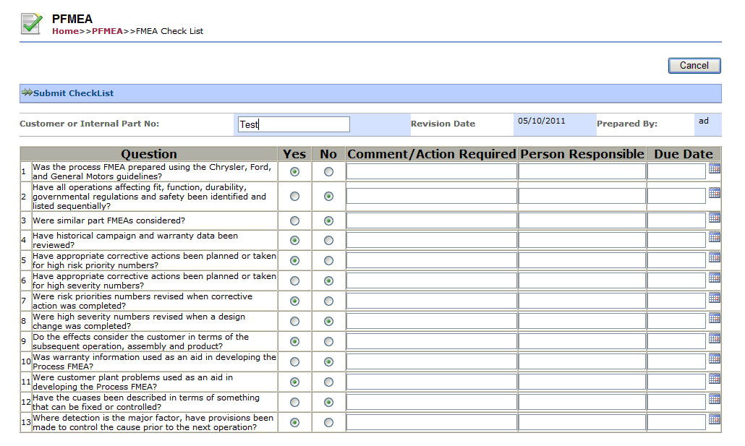
5. System Functionalities
5.1 PFMEA Form
This functional module consists of the following functions:
- Create New Form
- Approve Form
- Create New Check List
- View Form
Fig.5. Create New FMEA Checklist” Screen Design

Fig. 3. Create Form Process Flow

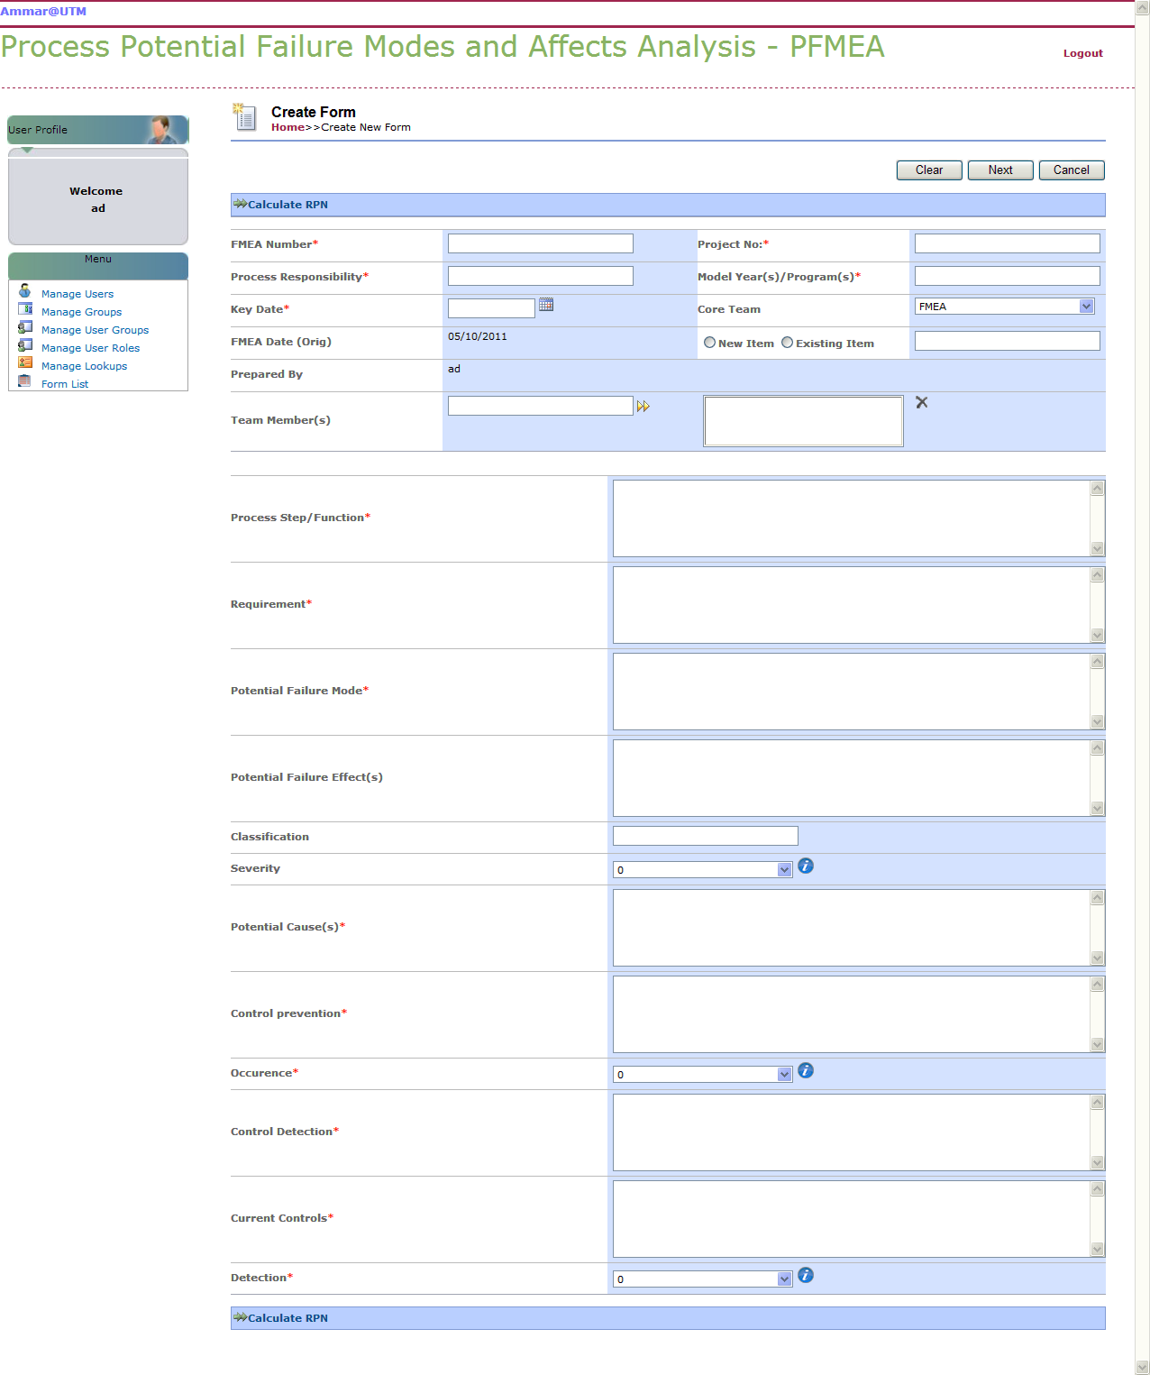

Fig.4. Create PFMEA new form screen design

5.2 Control plan functional module
This functional module consists of the following functions:
- Create Control Plan
- Create Control Plan Check List
- Approve Control Plan
Control Plan Process Flow
- The FMEA Requester receives the FMEA Form from the FMEA Approver and creates a Control Plan.
- The CP Approver will either approve/reject the Control Plan, if the services are no longer required.
- If the Control Plan is approved, the FMEA status is changed. If the Control Plan is rejected, the Control Plan is returned to the FMEA Requester for amendment and resubmission. The FMEA status is then changed.

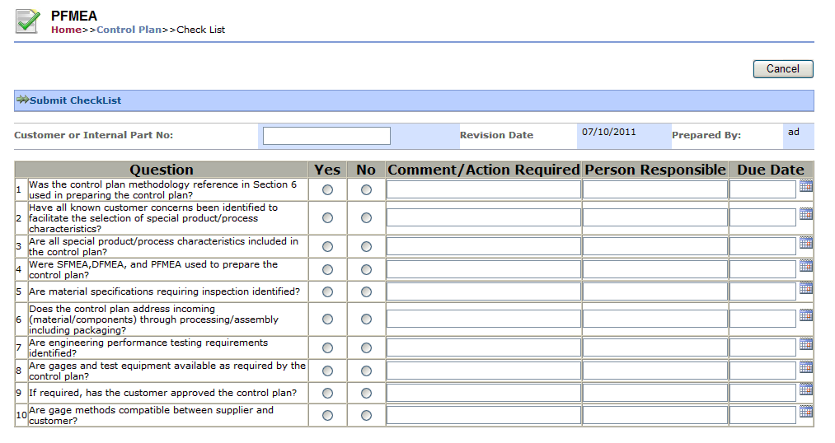
5.2.1 Create Control Plan
“Create Control Plan” allows the FMEA Requester to create a Control Plan for the PFMEA. However, once a Control Plan has been created and is in “Draft” version. They may edit the Control Plan that is in “Draft” version .

Fig. 8. Create CP Check List” Screen Design

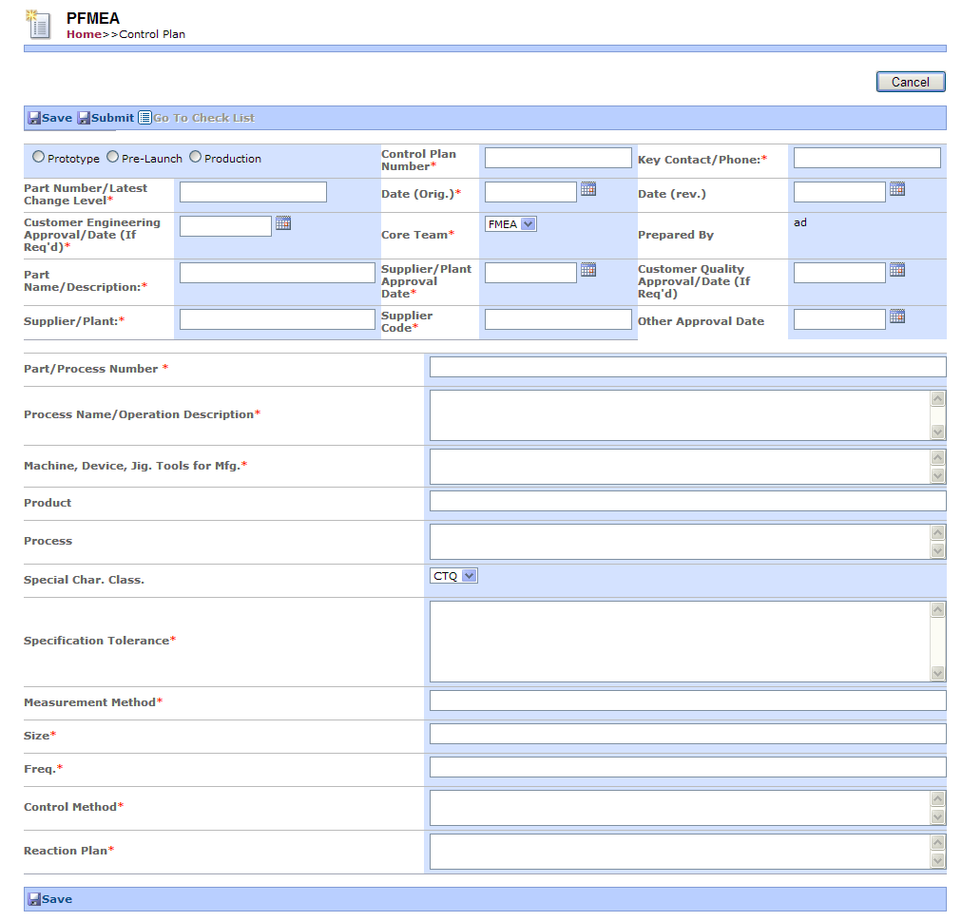
Fig. 6. Create control plan form process flow

Fig.7. Create Control Plan Screen Design

5.2.2 Create CP Check List
This function allows the FMEA Requester to create a CP Check List for submission to the Control Plan Approver. The CP Approver is then able to approve/reject the CP Check List along with Control Plan. This is a mandatory task and cannot be bypassed.

6. Discussions
Basically, there are three types of software tools needed in creating data driven applications, a modeling tool, a programming tool, and a database. In this research, Microsoft. Net Technologies was selected for programming reasons, such as ease of usage and availability. This is to ensure that the development cycle time is minimized, and the research objective can be met.
Microsoft. Net Technologies has matured into a robust and versatile development environment for both windows-based and web-based application development. With its emphasis on XML technology and Web Services, .NET allows businesses of all sized to take advantage of the Internet for distributed computational power.
Nevertheless, preliminary tests have been conducted within a limited scope. In terms of the usability, the prototype system has been tested within an industrial environment. Small sample size is one of the limitations in this approach.
This research was conducted within a single company in the automotive industry. Secondly, due to the time constraints of this research, only three in-depth case studies were conducted for theory building, and testing the prototype. The comprehensiveness and robustness might be improved if more test cases were applied.
However, the results and analysis are based on the information available.
In terms of performance, the prototype system is considered acceptable within the test environment in terms of the time required for creating the PFMEA worksheets, creating PFMEA checklist form, creating process control plan form,creating a control plan checklist form, and integrating the system with TRIZ, connecting to the remote database, and working with the system after it is downloaded at the client page. However, it is unclear if a similar acceptable performance can be achieved when the PFMEA web server, PFMEA database server, and the clients are distributed far away. Problems have been encountered when accessing the remote PFMEA database.
Future research could focus on enhancing this software to be much user friendly, improve the security level of the web browser, and use the system in early design stages.

7. Conclusions
FMEA is a methodology designed for identifying potential failure modes for a product or process, assessing the risk associated with those failure modes, ranking the issues in terms of importance, and identifying and carrying out corrective actions to address the most serious concerns.
In traditional FMEA, users face many difficulties due to the weaknesses of the current approach. An effective way to improve the effectiveness of the FMEA is to propose a support tool for a web technology that will allow the involvement of FMEA process services on the internet to overcome the convention FMEA limitations.
This paper is a significant attempt to employing internet technology to provide a PFMEA system for the automotive manufacturing firm in Malaysia, which fill the current gap of deficiencies in traditional FMEA. This approach will help the process engineer to take action proactively when updating FMEA and to improve or modify process control plans at a much lower cost. Integrated TRIZ with Web based FMEA can further assist in solving problems quickly and effectively. It also supports engineers look for the most highly effective and creative solutions.

AUTHOR BIOGRAPHIES
Ammar Ali Awad is an Enginering Dctorate candidate at Razak School of Engineering and Advanced Technology, Universiti Teknologi Malaysia. His areas of interests include Systematic Innovation including TRIZ, Manufacturing Management, and Web Based Manufacturing System, His email address is ammarpt73@yahoo.com

Sha’ri Mohd. Yusof is a Professor in Department of Manufacturing and Industrial Engineering, Faculty of Mechanical Engineering, Universiti Teknologi Malaysia (UTM), Skudai, Johor, Malaysia. He received his Ph.D from University of Birmingham, UK in 2000. His teaching and research interests is in Quality Management and Quality Engineering. He can be reached at shari@fkm.utm.my.

References
Annuar, K. (2005). Failure mode and Effect Analysis Management System for manufacturing process. Master thesis. Universiti Teknologi Malaysia.
Chen Eden H. C. (1996). Failure Modes and Effects Analysis Training Manual. Personal Communication. Chen Technology, Inc. United States.
Elmqvist J. Simin Nadjm (2008). Tool Support for Incremental Failure Mode and Effects Analysis of Component-Based Systems. IEEE computers in Industry, 60, 643-656.
Daniele, R. (2011). TRIZ tools to enhance risk management. Elsevier Ltd, 9, 40-51.
Daniel. (2006). The Effective Use of Process Control Plans and Process Failure Mode Effects Analysis in a GaAs Semiconductor Manufacturing Environment. Paper presented at the CS MANTECH Conference.
Hung, G. Q. (2000). Failure Mode and Effects Analysis (FMEA) Over the www. The International Journal of Advanced Manufacturing Technology 16, 603-608.
John Terninko, A. Z., and Boris Zlotin. (2000). Systematic innovation: an introduction to TRIZ ; (theory of inventive problem solving) London: St. Lucie Press Boca Raton .
Jui-Sheng 2008. A Web-based Framework of Project Performance and Control System. Robotics, Automation and Mechatronics. IEEE Conference 803 - 807.
Kaufman, J. a. S., Y. (2004). Value Analysis Tear-Down: A New Process for Product Development and Innovation,. New York.
Kim, J., Lee, Y., Lim W., Moon, (2009). Application of TRIZ creativity intensification approach to chemical process safety. Journal of Loss Prevention in the Process Industries, 22, 1039-1043
Mann, D. (2000). The Four Pillars of TRIZ. Paper presented at the invited paper at Engineering Design Conference.
MIL-STD1629A.(1980).Procedures for performing a failure mode, effects, and critical analysis, US Department of Defense.
Neagoe. (2010). The specifics of the application of the Failure Mode and Effects Analysis(FMEA) in the automotive industry. Paper presented at the international conference on Engineering mechanics, structures, engineering geology
Savransky, S. D. (2000). Engineering of Creativity (Introduction to TRIZ Methodology of Inventive Problem Solving). CRC Press, New York.
Stamatis,D. H. (2003). Failure Mode and Effect Analysis FMEA from Theory to Execution. Milwaukee: ASQ Quality Press.
Souchkov, V. (2007). Breakthrough thinking with TRIZ for business and management:An Overview. White Paper ICG Training & Consulting www.xtriz.com.
Teoh, P. C. (2005). An evaluation of failure modes and effects analysis generation method for conceptual design. International journal Computer Integrated Manufacturing, 18, 279-293.
Tien-Lun Liu1, S.-T. K. (2011). A Study of Applying TRIZ to Technological Patenting Deployment. International Journal of Systematic Innovation, 01.
Yen, S.-B. (2005). An Eco-Innovative Tool by Integrating FMEA and TRIZ Methods. Environmentally Conscious Design and Inverse Manufacturing, Fourth International Symposium 678 - 683 .

