## A TRIZ based method for making systematic innovation in Eco-design

Davide Russo a, Valentino Birolinia,

aUniversity of Bergamo, Engineering Department, Italy

a Corresponding author, E-mail: [davide.russo@unibg.it](mailto:davide.russo@unibg.it).

**Abstract**

Today innovation has to meet the environmental aspects. The ever increasing scarcity of resources and the higher level of pollution are orienting consumers and therefore industries towards a cleaner production and green products. Within a time to market which is constantly reducing, companies need tools to quickly develop new products which provide customer and business value together with a lower environmental impacts.

In this paper we propose a method to support innovation projects, taking into account also environmental requirements. The specific goal is to drive systematically the designer towards more sustainable products or processes, without interfering with its traditional design approach.

The method is based on an integration of Life Cycle Assessment LCA tools for collecting and processing information from all life cycle phases of the product, with a reworking of the TRIZ fundamentals (as the Ideal Final Results, Laws of Technical Systems Evolution and resources) for identifying where and how to intervene on it.

An application case is used to show the potentiality of the presented method.

*Keyword:* Eco-Design, Eco-guidelines, IFR, LCA,TRIZ.

## Introduction

During last decades, functions, quality, and cost were the unique aspects considered in products/processes design. Now the sensibility of consumers toward green products and process, and the governors’ directives oblige companies to consider Ecodesign. It is defined an approach to design of a product with special consideration for the environmental impacts of the product during its whole lifecycle.

Different approaches have been performed in order to face the environmental problems. The first one is the so-called “Pipe and chimney solutions”, in which the dangerous emissions were moved away from inhabited zones. With the progress of the urbanization, and due to the impossibility to move the dangerous emission away, they were treated with filters and with the so called ”End of Pipe Solutions”. The processes were less dangerous because the direct emissions to the environment are less, but they produced a great amount of waste. The following step was to implement cleaner and more efficient production processes in order to decrease the used resources and the discards. Actually the tendency is to make innovation adopting “Product Oriented Solutions”, considering the whole life cycle of a product. Adverse impact on the environment can indeed occurs in any life cycle stage, as material extraction, manufacturing, use, distribution and end of life.

So, companies needs to analyze and evaluate the impact of products during their entire life cycle (Tsai, Lee et al. 2011). Especially for small medium enterprises (SMEs) that is a time consuming and expensive activity, and it generally requires very specific competences, often extern to the company self.

Moreover companies have to quickly improve or develop new products with less environmental load, but although at the state of the art many systems are present for supporting SMEs to make green products, they are still too abstract for a direct and easily application (Crals and Vereeck 2005).

Additionally, we discovered that in eco-design it’s a common practice to under-evaluate the role of resources; actually, most methods focus only on materials and energy and with quite a superficial attitude. For instance the “companies’ guidelines” for the choice of material are limited to a simple classification that goes from good materials to be used freely to awful materials not to be taken into account (Luttropp and Lagerstedt 2006; Russo, Regazzoni et al. 2011).

By means of the combination of simplified evaluation environmental tools as abridged LCA with concepts from systematic problem solving practices, this paper provides a quickly and more effective method for designing more sustainable products. Particularly the integration of the IFR (Ideal Final Result)(Altshuller 1984) concept into the LCA method, allows to identify the most effective energy/material key point on which working on.

The introduction of other TRIZ concepts as the Technical Laws of system Evolution (LTSE) and resources(Altshuller and Rodman 1999) allows to transform the results of the previous LCA assessment into problems to be solved. A specific set guidelines for supporting the ECO-improvement has been prepared and introduced into the methodology to find easier and faster new solutions. They have been constituted by combining the more widespread environmental suggestions with the TRIZ design philosophy and tools.

In the subsequent paragraphs, a literature review of methods and tools for eco-innovation introduces to the proposed method. A case study is then presented with qualitative and quantitative results, with the aim of defining limits and potentialities of that method.

## State of the art of the Eco-Design tools for SMEs

In former times, engineers were only concerned about achieving design to cost and/or performance. The natural consequence was the manufacturing industry has been accused of operating a system that takes, makes and wastes, although it also has the potential to become a creator of products that generate ecological, social and economic value (Knight and Jenkins 2009).

One possible way to improve on this viewpoint was for industry to embrace the ‘eco-efficiency’ approaches providing a beneﬁt to the customer/user at the lowest environmental/economic ‘‘cost’’ (Luttropp and Lagerstedt 2006). In order to fulfill this goal, many methods and tools have been developed in the last decades, working on different levels of design (for product improvement, product redesign, new product concept, new production system definition) (Brezet 1997).

Byggeth (Byggeth and Hochschorner 2006) offered a classification of Eco-design tools in five classes according to their specific goal:

1. method and tools for the assessment of environmental impacts;
2. method and tools for the identification of environmental critical aspects;
3. method and tools for the comparison of environmental design strategies;
4. method and tools for the comparison of product solutions;
5. method and tools for the prescription of improvement strategies.

More generally the firsts four classes can be grouped in a wider category defined as analysis and assessment, while the last class is dedicated to the improvement (Le Pochat, Bertoluci et al. 2007).

## Eco-Assessment tools

Eco assessment and benchmark environmental tools have been developed since the last three decades (Finnveden and Moberg 2005; Ness, Urbel-Piirsalu et al. 2007), taking an huge magnitude of different approaches. One group includes those tools that focus their attention on material or energy flows, as MFA (Material Flow Accounting), TMR (Total Material Requirement), DMI (Direct Material Input), DMC (Direct Material Consumption), MIPS (Material Intensity Per Unit Service), SFA (Substance Flow Analysis) and EN (energy analysis). Furthermore, there are other approaches which take into account environmental impacts at a wider point of view: LCA (Life Cycle Assessment), SEA (Strategic Environmental Assessment), EMS (Environmental Management System) and EIA (Environmental Impact Assessment) belong to this group. Finally there are those tools and methods that also include economic aspects, as CBA (Cost-Benefit Analysis), LCC (Life Cycle Costing), SEEA (System of Economic and Environmental Accounts) and IOA (Input-Output Analysis).

Amongst different environmental assessment tools and methods, LCA is the most established, well-developed and effective tool to evaluate the environmental impacts of a product throughout its life cycle (Le Pochat, Bertoluci et al. 2007). It is an approach which analyses real and potential impact that a product has on the environment during raw material acquisition, production process, use, and disposal of the product (Ness, Urbel-Piirsalu et al. 2007).

Although the interest in LCA grew rapidly during the 1990s, and a strong development and harmonization has occurred (Finnveden, Hauschild et al. 2009), many authors identified some weaknesses in the LCA approach, hoping for its further developments (Finnveden 2000).

The main barriers to a wider LCA diffusion are (Consultants 2000; Hur, Lee et al. 2005):

* complexity of data collection;
* complexity of interpretation of results;
* expensive Software and databases;
* high LCA required knowledge;
* no support provided to designers to improve situation AS-IS.

Therefore, there is a need for simplified methods that involve less cost, time and effort, but yet provide similar results (Hur, Lee et al. 2005).

So specific simplified (or abridged or streamlined) LCA methods have been developed (Hochschorner and Finnveden 2003; Hur, Lee et al. 2005) and different depth levels of LCA analysis were defined (Wenzel 1998).

In order to improve LCA approach, some specific projects have been supported by the European community such as the E-LCA and E-LCA2 projects (Buttol, Buonamici et al.). These projects’ goals were to develop a simplified LCA tools and databases, called EverdEE (Masoni, Sara et al. 2004) for simplifying the methodological aspects of ISO 14040, minimizing time and resource investments and not requiring people skilled in LCA. Good results have been obtained at level of environmental impacts assessment , thanks to a clear and ease interaction with an huge database of substances, but several efforts are still needed mainly to identify the environmental critical aspects, to compare different solutions and to prescribe improvement strategies.

This work tries to overcome these eVerdEE‘s weaknesses in a more complete methodology dedicated to SMEs.

## Eco-Improving tools

Tools dedicated to product/process eco-improvement can be grouped mainly in two categories: guidelines and checklists (Fitzgerald, Herrmann et al. 2007).

Checklist are a list of questions which enterprises can easily use checking the presence of features of a reference system (Le Pochat, Bertoluci et al. 2007).

Guidelines are indications which provide broad support, with little detail, but applicable either across the whole product development process and lifecycle, covering a significant area (e.g. design for X) (Knight and Jenkins 2009).

Although the use of checklists easily suggests environmental weakness of the analyzed system, they don’t suggest how to concretely reach the target of the feature out of value, but provide only abstract strategies of action without giving concrete innovation suggestions.

In addition, despite their apparent benefits it’s unclear if also guidelines are effectively used and if they have any real effects on product system innovation (Luttropp and Lagerstedt 2006). Indeed some researches indicate that their application by SMEs is limited (Baumann, Boons et al. 2002). The main reason is the poor level of detail and the scarcity of indication for implementing the guidelines in a practical way (Crals and Vereeck 2005).

## Proposal

Based on this analysis, we defined a methodological framework that introduce several novelties to the current state of art of ECO-Design methods and tools. The main proposal are the following:

* Information are collected adopting design techniques for process modeling, that works as interface of LCA tools used to assess automatically the environmental impacts. In this way also people not skilled in LCA can calculate the impacts just working through energy and material flows, already organized by life cycle phases.
* The identification of environmental critical aspects is not demanded to LCA tools but it is conducted with a new design phase based on TRIZ IFR concept. We introduced the concept of “maximum potential reduction of impact” instead of “the maximum impact” caused by a flux. Furthermore, in order to near users to this approach the hot spots are graphically managed directly on the map of the process so avoiding any graph or statistic.
* The improvement phase is dedicated to translate the hot spots in real problems to be solved. For the problem solving phase we have adopted the most structured problem solving methods, like TRIZ, rearranging them from a green perspective and making them usable by non -experts too. A wide set of ECO-guidelines, obtained combining Triz based suggestions with best Ecodesign practices, is provided.

These proposals are finally combined in a unique framework addressed to make ECO-Design accessible to SMEs.

## 4. Framework overview

Due to the necessity to create an easy and effective method for guiding SMEs in the eco-innovation process, LCA software and eco-guidelines have been integrated in a wider system in order to jointly provide a quantitative assessment of products’ or processes’ ecological impact, and a relevant improvement strategies for designers.

*The assessment of environmental impacts*

The LCA assessment approach has been chosen as a foundation system in order to integrate inventing TRIZ capabilities to provide a more efficient approach.

The first novelty proposed in this work is that LCA assessment is not directly done on LCA software, but a more friendly process map, based on the IDEFØ (Integration Definition for Function Modelling), that is a method designed to model the decisions, actions, and activities of an organization or system by a graphic modelling language.

This allows an important simplification for users not skilled in the art.

The aim of this modelling phase (see Fig. 1) is to clear visualize all the data and additional information of processes and products, in order to automate the eVerdEE SW compilation. The AS-IS situation map allows to show clearly all material and energy flows as well as their loops, with the values really used into *eVerdEE* SW during the quantitative analysis.

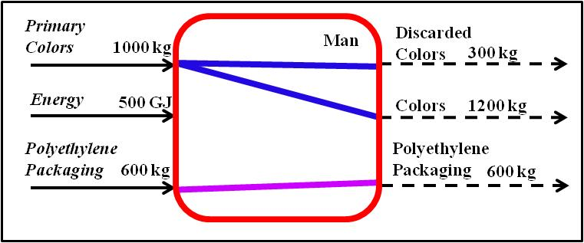

Fig. 1. IDEFØ modelling is used to collect gate to gate product and process information.

In order to visualize the environmental critical aspects, a similar map (see fig.2) is proposed to visualize the quantitative impact of each flow on each considered environmental indicator. Every map shows the impact calculated with eVerdEE. Every flux is converted in its percentage impact rate: more high is the percentage rate, more high is the size of the arrow which refers to that flux. Figure 2 shows the material and energy flows characterizing one of the painting activities in the manufacturing phase of a coloured tissue.

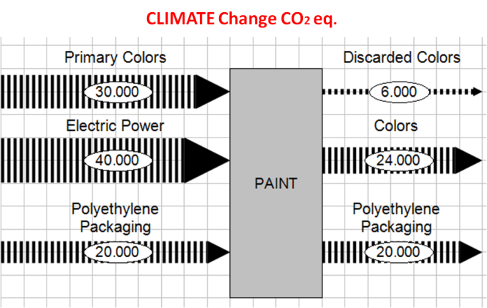

Figure 2 The map shows the impact on climate change (CO2 eq.) of the main 3 flows characterizing one of the painting activities in the manufacturing phase of a coloured tissue.

*The identification of environmental critical aspects by IFR*

The aim of this phase is to identify the hotspot, that is the flux with the greater potential improvement. To reach this goal IFR index is applied to every flux to weight how could be potentially reduced with a radical implementation.

By means of the definition of the Ideality and IFR concept, Genrich Altshuller was the first to realize that the direction of progress, or technical evolution, is defined by increasing the ideality level (Altshuller and Rodman 1999).

For a technical system the ideality can be defined as:

$$Ideality= \frac{\sum{Useful functions}}{\sum{Harmful functions}+\sum{Cost}} (1)$$

All systems become more ideal during their evolution and different strategies to accomplish it can be applied (Petrov and Seredinski 2005).

Applying IFR means to rethink the redesign each part of our process according to the following definitions of ideal machine, methods, process, substance and technology (Savransky 2000):

* the ideal machine which has no mass or volume but accomplishes the required work;
* the ideal method which expends no energy or time but obtains the necessary effect in a self-regulating manner;
* the ideal process which actually is only the process result without the process itself: momentary obtaining of a result;
* the ideal substance which is actually no substance (a vacuum), but whose function is performed;
* the ideal technique which occupies no space, has no weight, requires no labor or maintenance, and delivers benefit without harm, etc., and “does it itself,” without any additional energy, mechanisms, cost, or raw materials.

Starting from these definition, the Ideal Final Result (IFR) is the theoretical best solution of a problem for the given conditions.

Based on the IFR concept, an engineer can make “a step back from Ideality”, that from an ECO-design point of view means no energy or material and consequently zero pollution. Stating the IFR and retreating from it as little as possible offers strong technical solutions, due to the possibility of designing the system that works almost without environmental impact. The application of IFR can result in an elimination of a flux, a strong reduction moving to best available technology or the introduction of a recycling loop.

For example, as shown in fig. 3, taking into account the amount of energy used by a torch, the IFR application can be interpreted as a elimination of additional chemical sources by exploiting non pollutant resources as solar, or manual energy, or just as a strong reduction in the use of energy looking for low consumption technology as led.  
 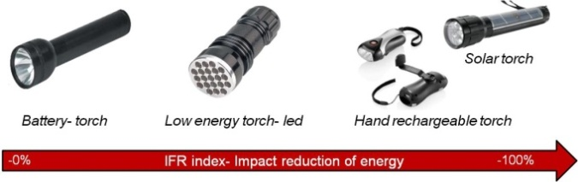

Figure 3- An example of IFR Redesign on a battery torch. IFR thinking forces to conceive solutions not using any pollutant sources as the han drechargeable or solar torches

A the same time IFR forces to imagine to introduce a recycle loop in order to stop the material consumption or recover unemployed energy. For example, as shown in fig. 4, taking into account the amount of paper used by a printer, the IFR application forces to imagine how to stop paper consumption, suggesting to move to recycled paper or towards new technologies for erasable and rewritable paper.

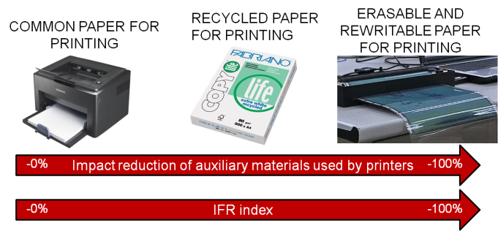

Figure 4- An example of IFR application on paper for printing. IFR means to 100% recycle paper without any pollutant material addition as in the case of erasable paper.

The application of IFR consists in re design every flow of the map assigning the percentage rate of virtual reduction in the ideal situation (see fig.5).

Adopting this index we are capable to associate each flow of energy or substance in input with the maximum potential reduction that can be theoretically achieved. Fig.5 shows the new ranking compared to that in figure 2: polyethylene packaging is now on top, because it can be totally eliminated, while primary colours is on the bottom. According to the new rank, it is suggested to work first on packaging and then reducing energy flow.

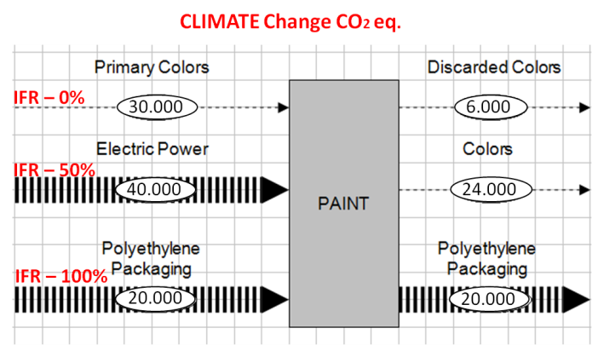

Figure 5- The map shows the new impact on climate change (CO2 eq.) of the material and energy flows calculated by introducing IFR index.

A sensitivity analysis on all flows based on realistic design criteria is so performed. Using this new index the assessment is then made not only on actual criticality of existing flows but also on possible future theoretical improvement.

Applying the IFR index to each flux calculated by LCA SW, fluxes which initially have the greater impact, often are not the primary hot spots on which operate.

That means the application of the IFR index can overturn the initial ranking of the percentage impact rate of the considered fluxes.

*The prescription of improvement strategies*

Genrich Altshuller has developed an analytical approach for technology forecasting and its theoretical foundation is a set of “Laws of Technical Systems Evolution”. These laws can be used for a judicious analysis and evaluation of the future designs of the systems of interest (Fey and Rivin 1999); at the same time they can be evaluated as a potential ally for existing eco-improvement methods (Jones and Harrison 2000; Russo and Regazzoni 2008).

Particularly, the tendency of some TRIZ fundamental such as ideality and laws of technical systems evolution (Altshuller 1984) is to lead the existing technical systems toward ideality (Russo, Regazzoni et al. 2011). This process starts working from a resource use optimization (particularly material, energy and spatial resources) till a their complete disappearance. Our goal was to translate this process in the form of practical eco-guidelines (Russo, Regazzoni et al. 2011).

These guidelines have been extracted from the TRIZ laws of evolutions (Altshuller 1984), and so their main theme is to reduce resource consumption (mainly material and energy and space) and to increase systems’ efficiency. This is possible by taking into account the best heuristics and theories of problem solving, and also taking into account new trends, technologies and best practices in green design.

According to the structure of LTSE in the first versions only eight guidelines were developed. They were conceived with the aim of improving the initial system in the phase of use and they were directed mainly for TRIZ experts.

That work was then extended to all phases of the product life cycle, and new directions for action were added. At present, the guidelines constitute over 330 actions organized by pre-manufacturing, manufacturing, product use and end of life.

They are conceived to support the designer for improving a product, a process or a service according to their own “green requirements” until the end of the problem solving process. Eco-guidelines contain very detailed suggestions and strategies to solve problems, tricks and best practices in ECO-Design, best available technologies and more other (see fig. 6).

Each life cycle phase set of guidelines contains a list of objects to which the guidelines refer to. For every object there is a list of potential goals, opportunely translated in terms of resource abatement. For making a better product, user has to reach much goals as possible for increasing the energy efficiency, decreasing the material exploitation and the volume, both directly on the product and for all other auxiliary related products and processes (Russo 2011). The existent architecture of that guidelines works firstly on system efficiency, on technologies substitution and secondly on flows substitution and optimization. Indeed the first step of each goal offers a way to interpret and follow the IFR strategy.

If the solution is obtained by eliminating or reducing only existing flows (without introducing any new ones), automatically the reduction of environmental impact is given, while if the solution requires adding a new flow to the previous system, then it is necessary to realize a new LCA calculation taking into account the variants on the overall phases of the process. Only in this way it is possible to verify the global effectiveness of the improvement action.

Among all the directions from “Guideline # act on packaging in use phase” one of them suggests reduce the packaging mass.

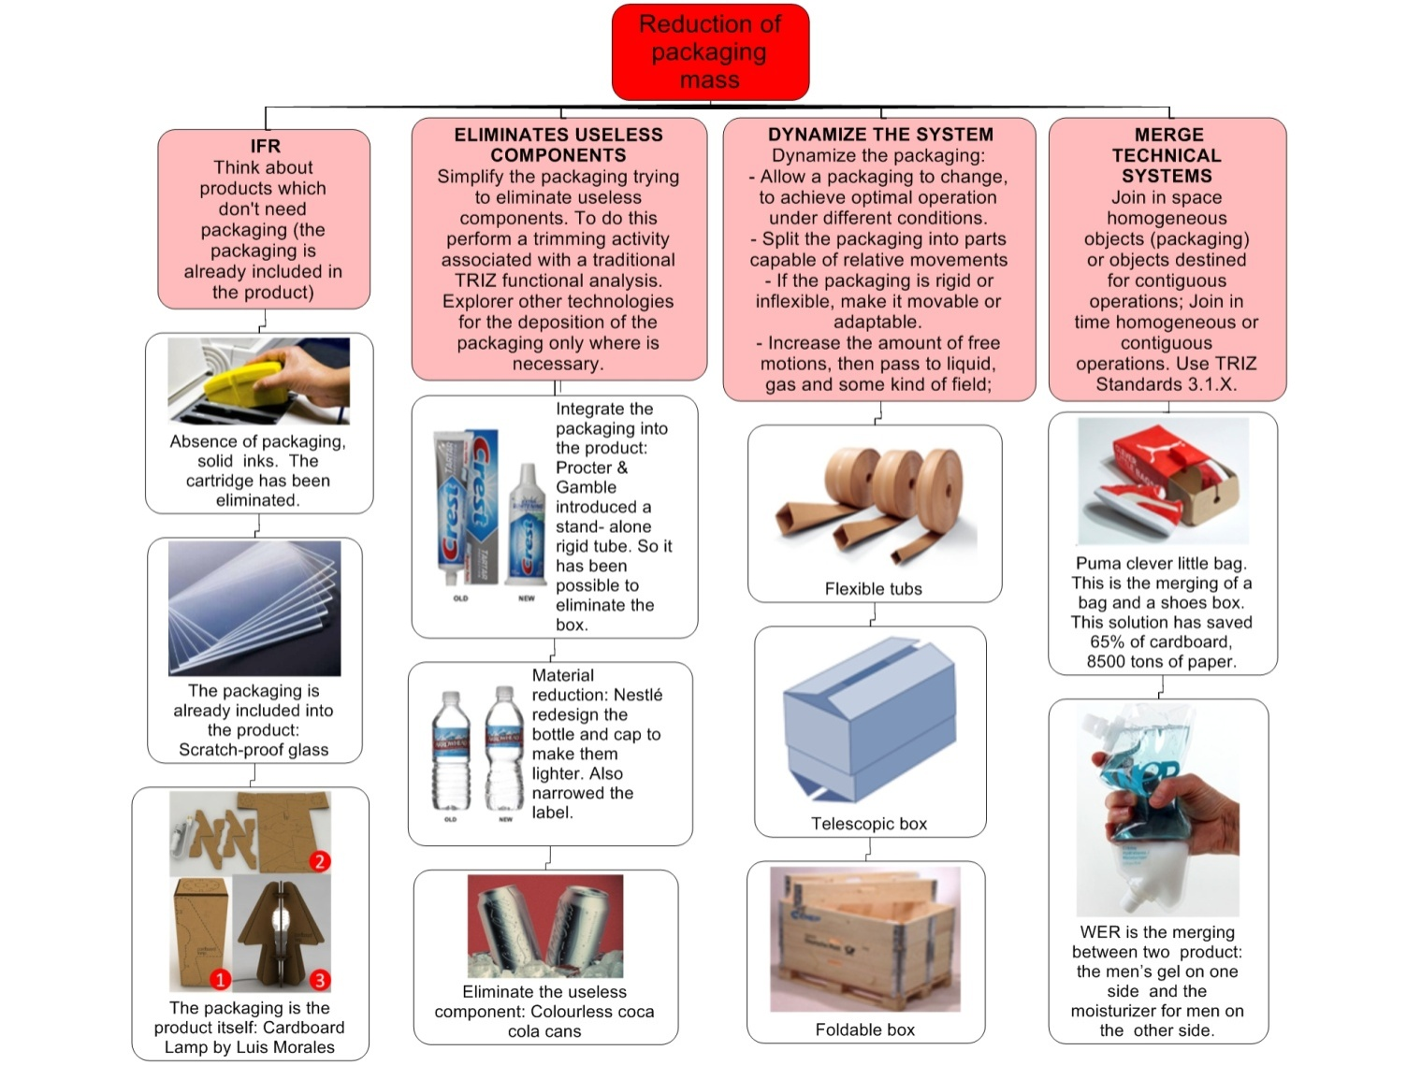

Figure 6. Example of a set of the 330 guidelines dealing with how to “*reduce the packaging mass”*.

## Case study

The case study concerns an industrial textile home-furnishings and bed linens painting company. The company itself produces the machines for painting and produces over 30 million m2 of coloured fabric.

Actually the process can be synthetically described by four different phases:

Pre-manufacturing: pigments and varnishes are prepared combining additives and other substances with water. Then auxiliary devices mix and transport the colours into the painting machines.

Manufacturing: four painting machines manage the colour delivery onto the fabric; another device recovers extra painting and cleans the dirty parts of the machines and auxiliaries. Another important phase of the manufacturing is post painting: here all processes dealing with drying are grouped: polymerization, vaporization, surface treatment, extra colour removal, and packaging).

Use: the phase of use of the fabric is not taken into account, all other related aspects were put into the manufacturing part.

End of use: this phase concerns all treatments of wastes, polluted water, solid/liquid chemical substances, exhausted colours, gas etc.

All the main functions of the painting process have been filled into the IDEF0 diagram decomposing in energy flows and substances.

Compatible with the availability of data (type of substances and energies) of our simplified LCA software database, the quantitative data associated with each flow has been broken down as much as possible, to ensure better accuracy of the analysis (for example, instead of entering an aggregate date relative to paint flow, it has been broken down in each chemical substance that composes the paint).

*Assessment of environmental impacts*

Once the diagram is complete, all collected information mapped as input in the diagram are processed by eVerdEE in order to calculate results of the impacts of every flow.

The authors decided to focus only on a set of potential indexes as criteria to determine the hot points:

* amount of material flow (kg)
* amount of energy flow (MJ)
* consumption of non-renewable energy (MJ)
* consumption of fresh water (m3)
* climate change (kg CO2 eq.)
* acidification  (kg SO2 eq.)
* eutrophication (kg PO4 eq.)

Results for any environmental index are mapped in form of IDEF0 process map. According to LCA assessment, the map in Fig.7 suggests to intervene on white fabric (the biggest arrows among inputs).

The overall analysis allowed identification of the global environmental impact of the company. In particular, it emerged that every year the company produces 23,000 ton of CO2eq., where the fabric contributes 18,000t, energy (gas, electricity, gasoline) 1,600t, CO2 direct emissions a further 1,600t, nickel and steel 60t, chemicals for water treatment 60t, colours dyes 40t, etc.

In this analysis flows with the highest environmental impact are fabric and methane.

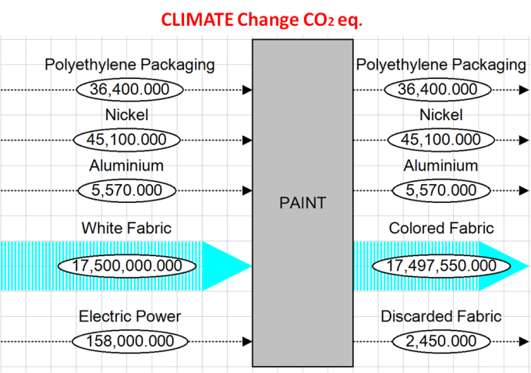

**Fig. 7.** IDEF0 model of aLCA results, before IFR index calculation

Here IFR index is introduced for any flow in order to evaluate where there could be the potential maximum reduction. Thus, a new ranking in provided, as shown in fig.8. The element with the highest potential impact can be visualized by the width of its arrow. In this case, the new IFR assessment suggests to act for reducing nickel impact, fabric waste and electric power. Ranking of LCA is upset; white fabric is not considered a strategic target in order to reduce CO2.

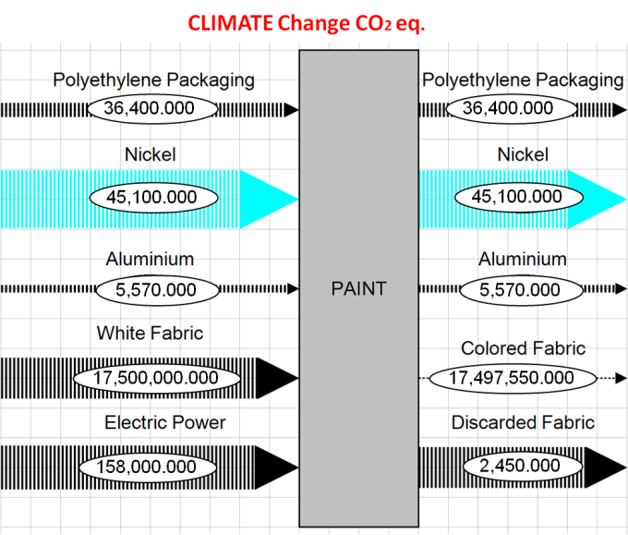

**Fig. 8.** IDEF0 model of aLCA results, after IFR index calculation

*The prescription of improvement strategies*

Next step consists in reducing elements in the top of IFR assessment as the Nickel.

Nickel is used in micro-perforated rolls employed in the painting phase. Every year over than 1,500 rolls of nickel are substituted and thrown away due to small deformations that appear on the external surface during the use and/or the removal phases.

Every roll is longer than 3 meters, it is constituted of a very thin sheet of nickel and it works in contact with the fabric that over time can make a dent that compromises the right functionality. Moreover, every roll is a very expensive component, it costs about a thousand euro.

This means if we introduce IFR index to eliminate nickel waste, it will be possible to reach both ecological and economic benefits.

Our new problem is to prevent the nickel tube is damaged or allowing its recovery.

This goal can be achieved by Eco-guidelines. There are several subset of guidelines that can be checked to find a solution. For the sake of brevity, we take into account just the maintenance set:

|  |  |
| --- | --- |
| 1 | re-design/use products with the highest reliability and requiring the lowest maintenance; |
| 2 | remove causes of damage or think about a self-repairing/self-regenerating object. |

This direction suggests preventing damage of the tube for example putting a metallic spiral inside the tube, as shown in fig. 10. This way can increase the robustness of the thin sheet metal of the tube, keeping it in traction and avoiding wrinkles on the external surface.

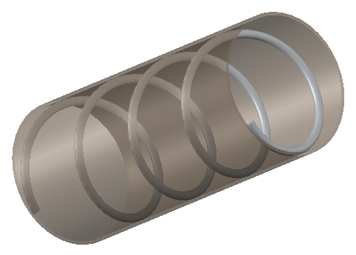

**Fig. 10.** Tube with an internal spiral which is maintained in traction with the tube.

In this way the increase in the useful life of the product has a positive impact on the reduction of the number of pieces used per year.

|  |  |
| --- | --- |
| 3 | re-design/use easy reparable products; think about modular products, for example using the segmentation. |

This direction can be achieved by avoiding employing a monolith tube and substituting it with a tube in more parts. So only damaged parts are removed and parts with the highest wear or with the highest probability of damage are made independent.

Segmentation can be achieved in different ways: a longitudinal segmentation and/or a transverse one, as the Fig. 11 and 12 show.

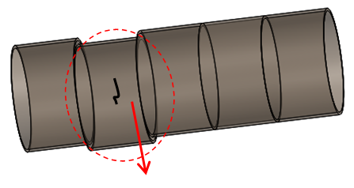

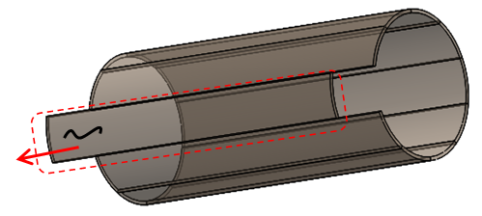**Fig. 12.** Schematic representation of the application of transversal and longitudinal the segmentation.

|  |  |
| --- | --- |
| 4 | re-design/use easy reparable products; think about modular products, for example using thermal deformation |

Another option suggests thermal deformation. Localized heat treatment can be used for regeneration of the tube by making a deformation in opposition to those that arise during painting dyeing deposition.

All proposed solutions are currently under study and evaluation because all of that could potentially produce strong saving in costs and environmental impact. In fact, by avoiding wasting the nickel or recovering it at 100%, we can save 45 ton of CO2eq., 8.9 ton of SO2eq., 6.9*105 MJ of non-renewable energy and 856 m3 of fresh water could be saved. For an economic evaluation we need to take into account that a single nickel tube costs about a thousand euro and that each production batch uses at least 20 rolls at once, for a total yearly consumption of several hundred units (equivalent to 3000 Kg of Nickel).

**Conclusions**

In this paper a new method has been presented for designing more sustainable products which meet the companies’ needs to have a simple and quickly method for product improvement or redesigning.

Mainly addressed for SMEs, this method aims to simplify the general path of an Eco-design approach and to make the classical environmental tools more effective, by means of the integration with concepts of a problem solving theory as TRIZ.

Particularly the integration of the Ideal Final Result (IFR) concept into classical environmental assessment tools as LCA allows to move the attention from the key points to work on suggested by a classical LCA to those ones which permit a greatest potential impact reduction.

Doing that the eco-design process can be more effective with a lower global environmental impact of the considered product/process.

Moreover, in order to help the designer to convert an abstract direction of intervention to a practical solution, the resource concept and the Laws of Technical Systems Evolution have been applied to create a new set of guidelines spitted up on the all life cycle phases.

The feasibility and the efficacy of the overall approach has been demonstrated by means of the application of the proposed method to an industrial case study concerning a textile home furnishing and bed linen painting dyeing company. The study was conducted downstream of a previous study aimed at obtaining environmental certification. A comparison between the new and the old production process reveals that the traditional critical points substantially overlap, whereas the introduction of additional assessment factors, such as the IFR factor, can generate new directions. IFR incites working on the flows with the largest potential reduction instead of the flows with the highest impact. Technical solutions are conceived by applying a list of pragmatic Eco improvement guidelines. In particular, an example for eliminating waste of nickel during the painting phase is shown. Actually, one of these improvements is currently being tested and could potentially produce a saving of 45 ton of CO2 and 8.9 ton of SO2, contributing significantly both to reduction of eutrophication and global warming, and costs.

The methodology will be tested in future on new case studies in order to verify its limit. A further development regarding harmonization of the 300 guidelines is also ongoing (Russo 2011).

**References**

Altshuller, G. and S. Rodman (1999). The innovation algorithm: TRIZ, systematic innovation and technical creativity, Technical Innovation Ctr.

Altshuller, G. S. (1984). Creativity as an exact science: the theory of the solution of inventive problems, CRC Press.

Baumann, H., F. Boons, et al. (2002). "Mapping the green product development field: engineering, policy and business perspectives." Journal of Cleaner Production 10(5): 409-425.

Brezet, H. (1997). "Dynamics in ecodesign practice." Industry and environment 20(1-2): 21-24.

Buttol, P., R. Buonamici, et al. "Integrating services and tools in an ICT platform to support eco-innovation in SMEs." Clean Technologies and Environmental Policy: 1-11.

Byggeth, S. and E. Hochschorner (2006). "Handling trade-offs in ecodesign tools for sustainable product development and procurement." Journal of Cleaner Production 14(15-16): 1420-1430.

Consultants, P. R. (2000). "Eco-indicator 99 Manual for designers." Ministry of Housing, Spatial Planning and the Environment, The Hague, The Netherlands.

Crals, E. and L. Vereeck (2005). "The affordability of sustainable entrepreneurship certification for SMEs." The International Journal of Sustainable Development and World Ecology 12(2): 173-183.

Fey, V. R. and E. I. Rivin (1999). "Guided technology evolution (TRIZ technology forecasting)." TRIZ Journal, January.

Finnveden, G. (2000). "On the limitations of life cycle assessment and environmental systems analysis tools in general." The International Journal of Life Cycle Assessment 5(4): 229-238.

Finnveden, G., M. Z. Hauschild, et al. (2009). "Recent developments in Life Cycle Assessment." Journal of Environmental Management 91(1): 1-21.

Finnveden, G. and Å. Moberg (2005). "Environmental systems analysis tools - an overview." Journal of Cleaner Production 13(12): 1165-1173.

Fitzgerald, D. P., J. W. Herrmann, et al. (2007). "Design for environment (DfE): strategies, practices, guidelines, methods, and tools."

Hochschorner, E. and G. Finnveden (2003). "Evaluation of two simplified life cycle assessment methods." The International Journal of Life Cycle Assessment 8(3): 119-128.

Hur, T., J. Lee, et al. (2005). "Simplified LCA and matrix methods in identifying the environmental aspects of a product system." Journal of Environmental Management 75(3): 229-237.

Jones, E. and D. Harrison (2000). "Investigating the use of TRIZ in Eco-innovation."

Knight, P. and J. O. Jenkins (2009). "Adopting and applying eco-design techniques: a practitioners perspective." Journal of Cleaner Production 17(5): 549-558.

Le Pochat, S., G. Bertoluci, et al. (2007). "Integrating ecodesign by conducting changes in SMEs." Journal of Cleaner Production 15(7): 671-680.

Luttropp, C. and J. Lagerstedt (2006). "EcoDesign and The Ten Golden Rules: generic advice for merging environmental aspects into product development." Journal of Cleaner Production 14(15-16): 1396-1408.

Masoni, P., B. Sara, et al. (2004). "VerdEE: a tool for adoption of life cycle assessment in small and medium sized enterprises in Italy." Progress in Industrial Ecology, an International Journal 1(1): 203-228.

Ness, B., E. Urbel-Piirsalu, et al. (2007). "Categorising tools for sustainability assessment." Ecological Economics 60(3): 498-508.

Petrov, V. and A. Seredinski (2005). Progress and ideality.

Russo, D. (2011). "A Computer Aided Strategy for More Sustainable Products." Building Innovation Pipelines through Computer-Aided Innovation.

Russo, D., Bersano, G. ,Birolini, V. , Uhl, R. (2011). "European testing of the efficiency of TRIZ in eco-innovation projects for manufacturing SMEs." Procedia Engineering 9: 157-171.

Russo, D. and D. Regazzoni (2008). TRIZ Laws of evolution as eco-innovation method. IDMME - Virtual Concept 2008, Beijing – China.

Russo, D., D. Regazzoni, et al. (2011). "Eco-design with TRIZ laws of evolution." Procedia Engineering 9: 311-322.

Russo, D., D. Regazzoni, et al. (2011). "Methodological enhancements for concept exploration in product design." International Journal of Product Development 15(1): 26-53.

Savransky, S. D. (2000). Engineering of creativity: Introduction to TRIZ methodology of inventive problem solving, CRC.

Tsai, J. P., R. S. Lee, et al. (2011). "Development of Eco-Innovative Framework and Methodology for Product Design." International Journal of Systematic Innovation 1(3).

Wenzel, H. (1998). "Application dependency of LCA methodology: key variables and their mode of influencing the method." The International Journal of Life Cycle Assessment 3(5): 281-288.

# aUTHOR BIOGRAPHIES

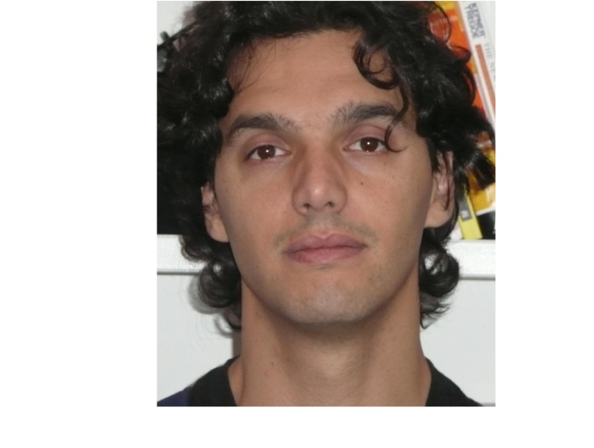**Davide Russo** took his degree in Mechanical Engineering in 2003, and his **PhD in Machine Design** in 2007 at University of Florence. Now he is working as **assistant professor** at University of Bergamo, Italy. Since 2003 he has been working in the field of **methods and techniques for innovation**. He has experienced creative thinking tools and methods aimed at systematizing the process of understanding and structuring problems. The results of his research activity are reported in over than **50 paper publications and 7 patent applications.** In particular, he is a Triz expert; the main subject of his PhD program has revealed how efficiently it can support a designer in his problem solving approach. At present, his main research is focused to create a new potential generation of **CAI tools**, both for **problem solving, for knowledge management and sustainable design**. He’s also interested in testing new technologies for text-mining as a means for supporting new product development activities.

**Valentino Birolini** took the master degree in Mechanical Engineering in 2009 at the University of Bergamo. Now he is working as **research assistant** at the University of Bergamo, since 2009. His main branch of study is **TRIZ** and theories for systematic innovation, taking into account problem solving methods with particularly regard for those ones aimed to understand and structure problems. The results of his research activities are reported in **8 paper publications and 1 application** of patent for invention.